**Namibia country profile**

Published

8 May 2018

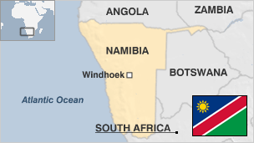

**Namibia, a large and sparsely populated country on Africa's south-west coast, has enjoyed stability since gaining independence in 1990 after a long struggle against rule by South Africa.**

Germany took control of the area which it called South West Africa in the late 1800s.

The discovery of diamonds in 1908 prompted an influx of Europeans.

South Africa seized it during the First World War and administered it under a League of Nations mandate.

Namibians achieved independence in 1990 after a bush war of almost 25 years. Inter-racial reconciliation encouraged the country's white people to remain and they still play a major role in farming and other economic sectors.

* Read more [country profiles](http://news.bbc.co.uk/1/hi/country_profiles/) - Profiles by [BBC Monitoring](http://bbc.co.uk/monitoring)

**President: Hage Geingob**

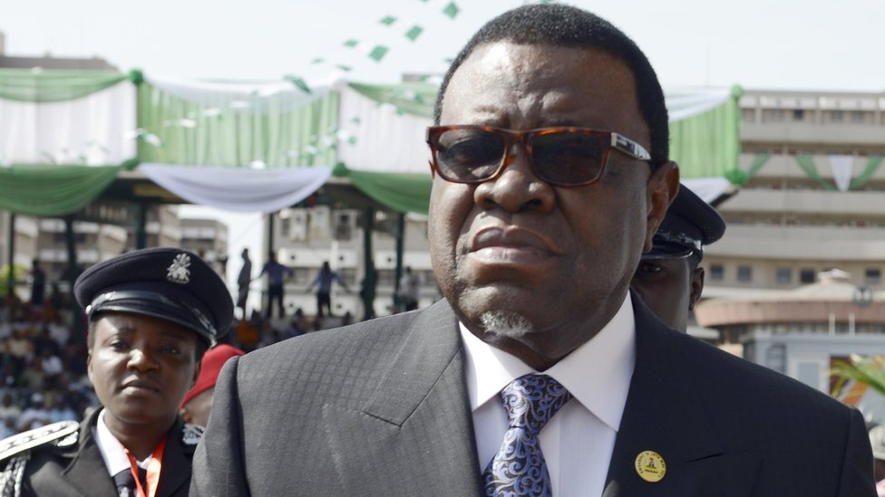image copyrightGetty Images

Hage Geingob was voted in as president in the November 2014 elections while serving as prime minister.

He succeeded Hifikepunye Pohamba, who stepped down at the end of the two terms allowed by the constitution.

Dr Geingob, who was born in 1941, chaired the constituent assembly which drafted the constitution which came into effect with Namibian independence from South Africa in 1990.

He was independent Namibia's first prime minister.

The president, who shares executive power with the cabinet, is limited to two five-year terms.

**Prime minister: Saara Kuugongelwa-Amadhila**

image copyrightGetty Images

Saara Kuugongelwa-Amadhila was appointed prime minister in 2015, having served as finance minister for several years.

A longtime member of the ruling South West Africa People's Organization (SWAPO), she went into exile with the group to Sierra Leone at the age of 13.

After completing her economics degree in the United States, Ms Kuugongelwa-Amadhila returned to Namibia and worked briefly in the office of founding President Sam Nujoma, who quickly promoted her to head the National Planning Commission.

She then served as minister of finance from 2003 until her promotion to the position of prime minister by President Geingob.

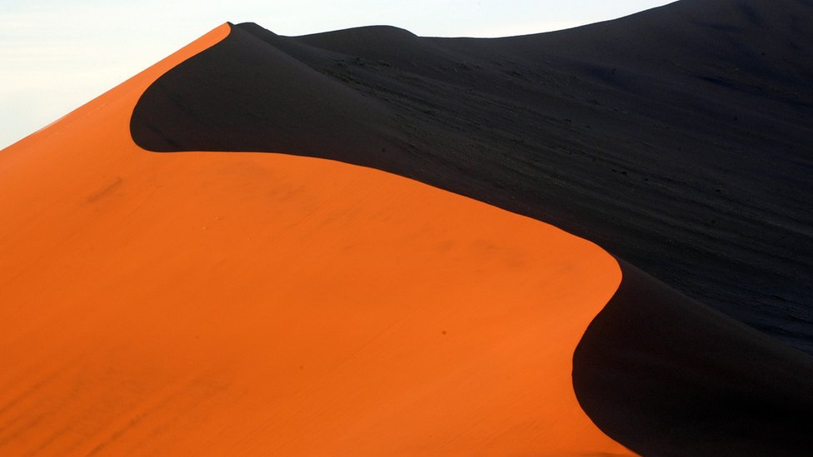

image captionNamibia has spectacular natural attractions, such as the dunes at Sossusvlei in the Namib-Naukluft National Park

Namibia is one of the more media-friendly countries in Africa.

Broadcasters and the private press give coverage to the opposition, including views critical of the government.

# Namibia profile - Timeline

Published

2 December 2019

## A chronology of key events:

**1488** - Portuguese explorer Bartolomeu Dias visits.

**1886-90** - Present international boundaries established by German treaties with Portugal and Britain. Germany annexes the territory as South West Africa.

**1892-1905** - Suppression of uprisings by Herero and Namas. Possibly 60,000, or 80% of the Herero population, are killed, leaving some 15,000 starving refugees.

## South African occupation

**1915** - South Africa takes over territory during First World War.

**1920** - League of Nations grants South Africa mandate to govern South West Africa (SWA).

**1946** - United Nations refuses to allow South Africa to annex South West Africa. South Africa refuses to place SWA under UN trusteeship.

**1958** - Herman Toivo Ya Toivo and others create the opposition Ovamboland People's Congress, which becomes the South West Africa People's Organisation (Swapo) in 1960.

**1961** - UN General Assembly demands South Africa terminate the mandate and sets SWA's independence as an objective.

**1966** - Swapo launches armed struggle against South African occupation.

**1968** - South West Africa officially renamed Namibia by UN General Assembly.

**1973** - UN General Assembly recognises Swapo as "sole legitimate representative" of Namibia's people.

**1988** - South Africa agrees to Namibian independence in exchange for removal of Cuban troops from Angola.

**1989** - UN-supervised elections for a Namibian Constituent Assembly. Swapo wins.

## Independence

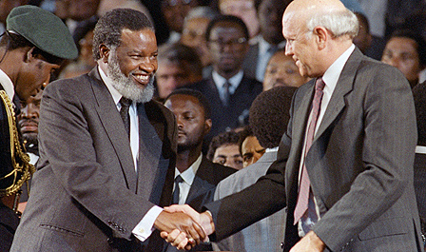image copyrightGetty Images

image captionIndependence celebrations: Namibia's new president Sam Nujoma shakes hands with President FW de Klerk of South Africa, which gave up rule over the territory

**1990 March** - Namibia becomes independent, with Sam Nujoma as first president.

**1994** - South African exclave of Walvis Bay turned over to Namibia.

**1998** - Hundreds of residents of the Caprivi Strip flee to Botswana, alleging persecution by the Namibian government.

**1998** August - Namibia, Angola and Zimbabwe send troops to the Democratic Republic of Congo to support President Laurent Kabila against rebels.

**1999** August - Emergency declared in Caprivi Strip following series of attacks by separatists.

**1999** December - President Nujoma wins third presidential term.

**1999** December - World Court rules in favour of Botswana in territorial dispute with Namibia over the tiny Chobe River island of Sedudu - known as Kasikili by Namibians.

**2002** August - New prime minister, Theo-Ben Gurirab, says land reform is a priority. President Nujoma says white farmers must embrace the reform programme.

**2004** May - Road bridge across Zambezi river between Namibia, Zambia opens amid hopes for boost to regional trade.

**2004** August - Germany offers formal apology for colonial-era killings of tens of thousands of ethnic Hereros, but rules out compensation for victims' descendants.

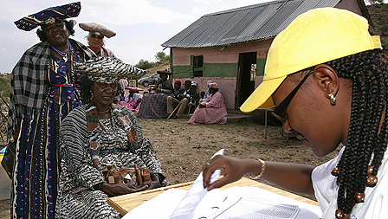image copyrightGetty Images

image captionHerero women prepare to vote in the 2004 presidential elections

**2004** November - Hifikepunye Pohamba, President Nujoma's nominee, wins presidential elections.

**2005** September - Government begins the expropriation of white-owned farms as part of a land-reform programme.

**2006** June - National anti-polio vaccination campaign is launched following the death of at least 12 people from the disease.

**2007** February - Chinese President Hu Jintao visits, signs aid and economic co-operation agreements.

**2007** August - Ten men are found guilty of treason for leading a secessionist rebellion in the Caprivi region and are given long prison terms.

**2009** November - Presidential and parliamentary polls. President Pohamba and his ruling Swapo party re-elected.

**2011** February **-** High Court dismisses legal challenge by nine opposition parties claiming irregularities in the 2009 parliamentary election.

**2011** July- Mines and Energy Minister Isak Katali says Nambia has found a possible 11bn barrels of offshore oil reserves.

**2011** October - Skulls of 20 Herero and Nama people repatriated from a museum in Germany to a welcome from hundreds of descendants.

**2014** August - A protester is shot and killed by police during a rare occurrence of political violence.

**2014** November - Hage Geingob is elected president, SWAPO wins parliamentary polls.

**2018** February - Politicians and civil servants are banned from all foreign business travel to cut expenditure. The economy has been hard hit by a drop in uranium revenues.

**2019** November - President Geingob wins re-election.